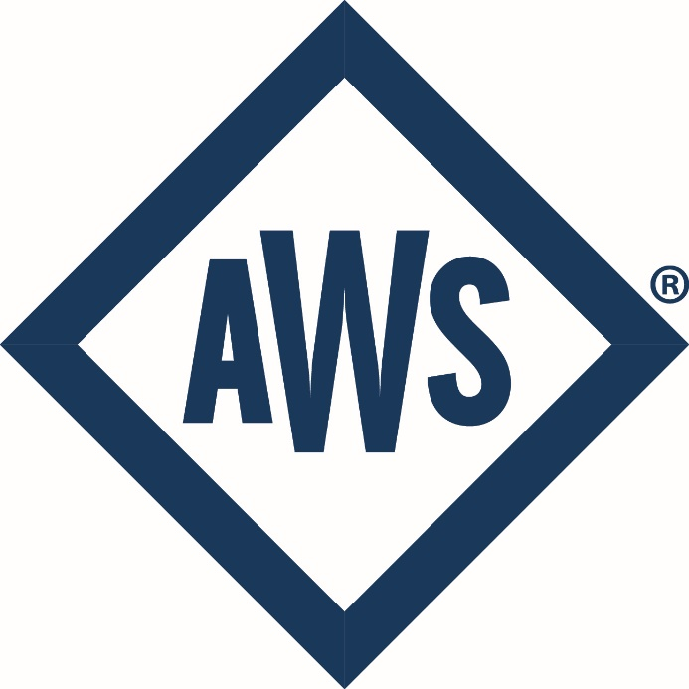

AWS

Nondestructive Examination Coordination

Endorsement Description

# Introduction

The AWS Nondestructive Examination Coordination Endorsement Description provides guidance in the endorsement examination process. AWS strongly advises those who apply for the endorsement examination to read the endorsement description, paying particular attention to the test specifications and content area to gain better understanding. The examination description is subject to change.

# Endorsement Scope

AWS QC1, Standard for AWS Certification of Welding Inspectors, provides for endorsements that may be added to the CWI and SCWI certifications. Endorsements are an indication of an additional knowledge, skill or ability documented in writing and added to an individual’s certification credential(s).

# Endorsement Candidate Eligibility Criteria

This endorsement meets a portion of the requirements for SWI Alternate Qualification in AWS B5.1 and Alternate Certification for the SCWI in QC1. The inspector who seeks the Nondestructive Examination Coordination endorsement should be assessed with the following capabilities:

* NDE qualification and certification programs. The endorsement holder should demonstrate an understanding of the programs and governing standards that determine how NDE agencies are assessed and what the training and certification requirements are for NDE practitioners.
* NDE methods. The endorsement holder should demonstrate an understanding of the basic elements necessary for each of the major NDE methods. This will prepare the holder to oversee the selection of the proper NDE method from the perspective of the advantages and limitations of each method.
* NDE Coordination. The endorsement holder should demonstrate knowledge of inspection test plans, sampling protocols, probabilities of detection, and how to interpret data collected from NDE reports.

# 

# Initial Certification or 9-year Recertification Eligibility

For existing CWIs and SCWIs, successful completion of this endorsement satisfies the examination requirements for recertification under Clauses 16.2.1 or 16.3.1, as applicable, of AWS QC1:2016-AMD1- *Specification for AWS Certification of Welding Inspectors,* provided that the endorsement is taken during the immediate 9-year period

IMPORTANT! For new candidates to the CWI program, this examination is not an option for initial certification. This is not a CWI Part C Codebook exam and thus does not meet the requirements of Clause 6.2.1 of the AWS B5.1:2013 AMD1- *Specification for the Qualification of Welding Inspectors,* nor does it follow the guidelines of Clause 7.1.

# Training Requirements

This endorsement has no mandatory training requirements. Candidates are encouraged

to attend an AWS seminar or to self-study to improve their familiarization.

# Examination Requirements

Candidates seeking the Nondestructive Examination Coordination Endorsement shall pass the Nondestructive Examination Coordination examination.

Successful candidates must correctly answer 72% of the questions to receive this endorsement. The reported scores are rounded down to the nearest lower whole percent number.

# Test Specification

The Test Specifications is a breakdown of the exam content areas or domains that appeared in the examination along with the proportion of the exam devoted to each content area.

|  |  |  |
| --- | --- | --- |
| **Domain** | **Subdomain** | **Percent of Questions on Examination** |
| **Domain 01 Qualification and Certification** | 0101 Standards for NDE Quality Management | **20%** |
| 0102 NDE Qualification and Certification Standards |
| **Domain 02 Methods** | 0201 Visual Testing | **30%** |
| 0202 Magnetic Particle Testing |
| 0203 Liquid Penetrant Testing |
| 0204 Radiographic Testing |
| 0205 Ultrasonic Testing |
| 0206 Leak Testing |
| 0207 Eddy Current Testing |
| 0208 Positive Metal Identification |
| **Domain 03**  **NDE**  **Coordination** | 0301 ITP-QP | **50%** |
| 0302 Data Analysis |
| 0303 Approved Operating Procedures |
| 0304 Selection of NDE Methods and Techniques |

# 

# Examination Details

The closed-book examination consists of 55 questions. Of the 55 questions, 50 will be scorable questions, and five will be unscorable (pretest) questions.

The examination is comprised of four multiple-choice items. Each question has only one correct response.

**IMPORTANT!** A Chinese language-assisted version of the exam is available. For a list of available international Agents and test locations, please click [HERE](https://www.aws.org/certification-and-education/professional-certification/international-agents/#agents).

The language assisted version of the exam will consist of **50** scorable traditional multiple-choice questions.

## Pretesting

The unscored questions are referred to as “pretest” questions. Including a small number of unscored test questions is common practice within the high stakes testing industry. It allows AWS to evaluate new items for both content validity and statistical performance. Items that perform well may be used in future examinations. This further helps future examination versions to have equivalent levels of difficulty and overall quality.

These questions are not scored and will not impact whether a candidate passes. These items are randomly placed within the examination and will not be identifiable as pretest items during testing.

# Informative References for Self-education

The following is a list of informative reference books to assist those wishing to take the Nondestructive Examination Coordination endorsement beta test.

|  |  |
| --- | --- |
| Document | URL |
| ANSI/ASNT CP-9712:2023  or  ISO 9712:2021 | [ANSI/ASNT CP-9712 (2023)](https://source.asnt.org/203se4b/?__hstc=82887177.6fa385653ecd7c9674ba06f08984886d.1712275200200.1712275200201.1712275200202.1&__hssc=82887177.1.1712275200203&__hsfp=892594048)  or  [ISO 9712:2021](https://www.iso.org/standard/75614.html) |
| ANSI/ASNT CP-189:2020 | [ANSI/ASNT CP-189:2020](https://source.asnt.org/1pekngo/) |
| API RP 578 | [API RP 578](https://www.apiwebstore.org/standards/578) |
| ASNT SNT-TC-1A:2024 | [ASNT SNT-TC-1A:2024](https://source.asnt.org/snt-tc-1a-2024/) |
| ASTM E1003-22 | [ASTM E1003-22](https://www.astm.org/e1003-13r22.html) |
| ASTM E1212-17 | [ASTM E1212-17](https://www.astm.org/e1212-17.html) |
| ASTM E1359-17 | [ASTM E1359-17](https://www.astm.org/e1359-17.html) |
| ASTM E164-19 | [ASTM E164-19](https://www.astm.org/e0164-19.html) |
| ASTM E165-23 | [ASTM E165-23](https://www.astm.org/e0165_e0165m-23.html) |
| ASTM E2884-22 | [ASTM E2884-22](https://www.astm.org/e2884-22.html) |
| ASTM E543-21 | [ASTM E543-21](https://www.astm.org/e0543-21.html) |
| ASTM E709-21 | [ASTM E709-21](https://www.astm.org/e0709-21.html) |
| ASTM E797-21 | [ASTM E797-21](https://www.astm.org/e0797_e0797m-21.html) |
| ASTM E94-22 | [ASTM E94-22](https://www.astm.org/e0094_e0094m-22.html) |
| AWS B1.10/B1.10M:2016 | [AWS B1.10/B1.10M:2016](https://pubs.aws.org/p/1680/b110mb1102016-guide-for-the-nondestructive-examination-of-welds) |
| AWS B1.11M/B1.11:2015 | [AWS B1.11M/B1.11:2015](https://pubs.aws.org/p/1547/b111mb1112015-guide-for-the-visual-examination-of-welds) |
| AWS B5.17:2014 | [AWS B5.17:2014](chrome-extension://efaidnbmnnnibpcajpcglclefindmkaj/https:/aws-p-001-delivery.sitecorecontenthub.cloud/api/public/content/AWS_B5.17-2014_SPECIFICATION_FOR_QUALIFICATION_OF_WELDING_FABRICATORS?v=476a51d2) |
| AWS D10.4M/D10.4 | [AWS D10.4M/D10.4](https://pubs.aws.org/p/2189/d104m-d104-2023-guide-for-welding-austenitic-stainless-steel-piping-and-tubing) |
| AWS Welding Handbook 10th Ed.  Vol. 1 | [AWS Welding Handbook 10th Ed. Vol. 1](https://pubs.aws.org/p/1918/whb-110-welding-handbook-volume-1-welding-and-cutting-science-and-technology-aws-whb-101) |
| ISO 9001 | [ISO 9001](https://www.iso.org/standard/62085.html) |

# References for Taking the Endorsement Examination

This is a closed book exam. Sufficient information to answer the question will be provided in the stem of the question; consulting a reference standard will not be necessary. If a reference is necessary to answer a question, the reference will be provided digitally with the question.

**IMPORTANT!** Candidates are not permitted to bring printed copies from the Informative References for Self-Education list to the test location.

# Exam Delivery

The examination is a computer-based test (CBT) delivered at a Prometric test center.

# CBT Exam Timing Information

The overall seat time allotted is 150 minutes (2.5 hours) for the English examination from check-in to check-out at the test center.

The time that can be used to answer questions is 135 minutes (2 hours and 15 minutes).

|  |  |
| --- | --- |
| **Section of English Testing** | **Time in Minutes** |
| Candidate Confirmation Page | 2 |
| Non-Disclosure Agreement (NDA) | 2 |
| Introduction & Tutorials | 10 |
| Exam Question Answering | 135 |
| Finish Page | 1 |
| Total | **150** |

## Language Assisted Examination

The overall seat time allotted is 135 minutes (2 hours and 20 minutes) for the Language Assisted examination from check-in to check-out at the test center.

The time that can be used to answer questions is 120 minutes (2 hours) for the Language Assisted examination.

|  |  |
| --- | --- |
| **Section of Language Assisted Testing** | **Time in Minutes** |
| Candidate Confirmation Page | 2 |
| Non-Disclosure Agreement (NDA) | 2 |
| Introduction & Tutorials | 10 |
| Exam Question Answering | 120 |
| Finish Page | 1 |
| Total | **135** |

# Endorsement Fee Structure

For candidates in the United States and Canada, exam fees are due at time of registration and are paid directly to AWS. For the AWS exam price list, click [HERE](https://aws-p-001-delivery.sitecorecontenthub.cloud/api/public/content/certification-education-pricelist).

For international (outside of the US and Canada) candidates, exam fees are due at time of registration and paid to the International Agent representing AWS. Agents can provide pricing information regarding international exams.

# Endorsement Credential

Endorsements earned will be updated in the AWS certification profile. Status can be checked via the QR code on the back of the CWI wallet card or via the [**Quikcheck web link**](https://www.aws.org/certification/onlinecertificationverification).

# Renewal Requirements

The endorsement does not have any requirements for renewal. It will automatically be renewed at each CWI renewal or recertification. The endorsement will continue to be listed in an approved manner.

# Professional Development Hours

# Candidates who successfully complete pre-exam training to prepare for the Non-destructive Examination Coordination endorsement examination may gain PDHs in accordance with QC1 clause 16.5.

# Candidates who successfully pass Non-destructive Examination Coordination endorsement examination and desire to gain PDHs should contact the AWS Certification Department.