Sections Promotions Calendar – July through December 2025

Hello AWS Section Leaders! This document is intended to help you share upcoming events & content on the AWS section pages that you manage. Please note the timelines intended for the content, and feel free to use the talking points to create your own personalized captions for your post, utilizing the suggested hashtags at the end of your caption. Have questions? Send them to [social@aws.org](mailto:social@aws.org)

* FABTECH 2025
  + Timeline: July through September, event takes place September 08-11, 2025
  + Talking points:
    - Join AWS for four days of cutting-edge education, expert-led sessions, and hands-on experiences that move the industry forward.
    - Whether you're a student, educator, professional, or executive, FABTECH offers learning opportunities to help you meet your goals.
    - Celebrate the AWS community at FABTECH. AWS hosts a variety of valuable events–exclusively for members. This year, catch-up with fellow members, find out who won the National Awards and Foundation Scholarships, network with industry professionals, and more.
  + Hashtags: #fabtech2025 #awsatfabtech #futureofwelding
  + Image:

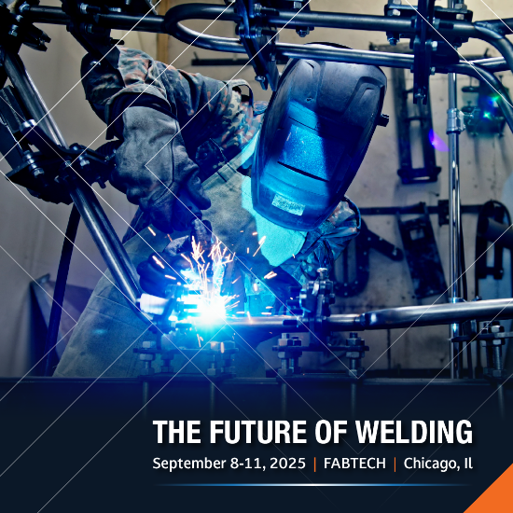

* Section Scholarships
  + Timeline: December 1, 2025 through March 1, 2026
  + Talking points:
    - Many AWS Sections have scholarships funded by local members, companies, and donors, designated for students in the Section. Scholarships range from $1,000 to more than $3,000+.
    - The deadline to apply for National, District, and Section Scholarships is March 1st.
    - District and Section Named Scholarships are selected by local committees of AWS Section Officers and Members.
  + Hashtags: #awsscholarships #weldingscholarships #awsfoundation
  + Image:

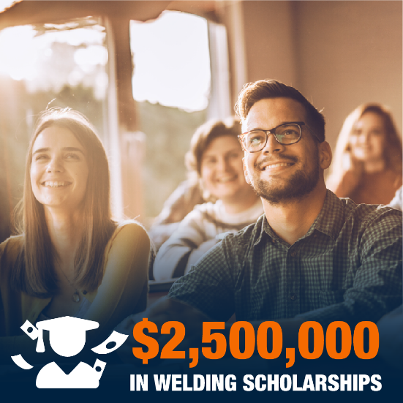 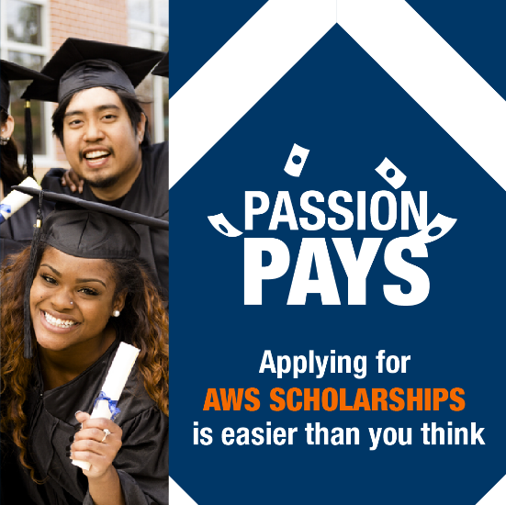

* ASME Section IX Workshops
  + Timeline: now through December 2025
  + Talking points:
    - This comprehensive three-day workshop designed to simplify ASME Section IX requirements for Welding, Brazing, and Fusing Qualifications. you’ll learn how to write cost-effective welding procedures, qualify welders efficiently, and gain a practical understanding of key processes.
    - Attendees will receive a hard copy of the newly released 2025 ASME Section IX Edition
    - Attendees can earn up to 24 PDHs.
  + Hashtags: #ASMEsectionIX #ASMEworkshops #weldingqualification
  + Images:

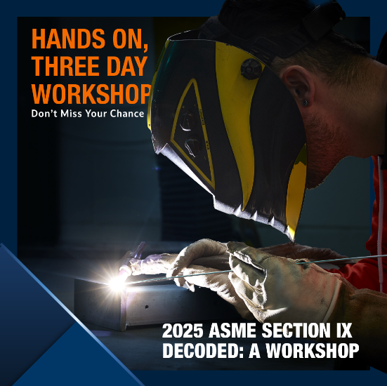 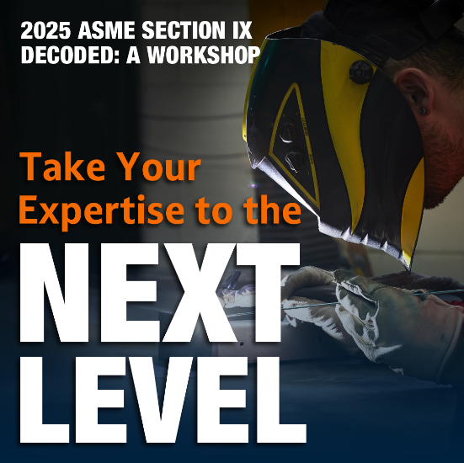

* Pipeline, Facilities, and Tanks Conference
  + Timeline: event takes place November 5-6, 2025
  + Talking points:
    - Join us at the premier pipeline welding conference in Fort Worth for an in-depth exploration of the interconnected industries of pipelines, tanks, storage tanks, and related facilities
    - This event will bring together professionals from engineering, construction, inspection, maintenance, asset integrity, and more to discuss advancements, challenges, and innovations shaping the industry.
    - Additionally, attendees are awarded 1 PDH (Professional Development Hour) for each hour of attendance—for a total of 9 PDHs—making this a valuable PDH oil & gas Fort Worth event. These hours can be applied toward AWS recertifications, renewals, and other professional requirements.
  + Hashtags: #piplineconference2025
  + Images:

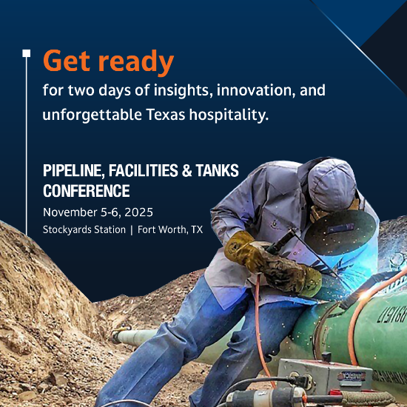 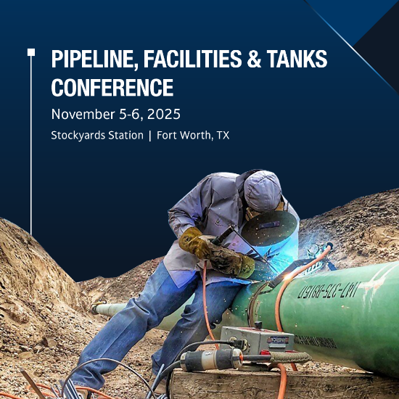

* Welding Apprenticeships
  + Timeline: now through end of year
  + Talking points:
    - American Welding Society (AWS) Registered Welding Apprenticeship Programs support the future of this in-demand workforce by producing top-quality welding professionals.
  + The American Welding Society currently offers three approved Registered Welding Apprenticeship Programs: AWS Certified Welder, Welding Inspector and Welding Automation.
  + Hashtags: #weldingapprenticeships #weldingworkforce
  + Images:

