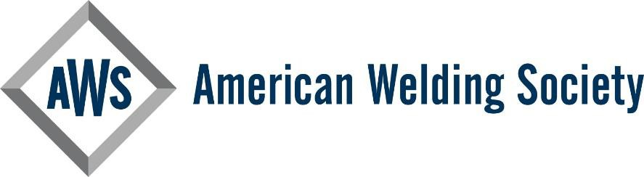

Certified Welding Inspector

Lifetime Achievement Award Nomination Package - Class of 2025

I.R. Nominee

Template Instructions:
This template is provided as a tool for submitters to use in composing a nomination package as outlined in the CWI Lifetime Achievement Award Guidelines Document. This template is simply provided as an aid to the package submitter to help organize information about the nominee. It may be modified as appropriate to best represent the nominee. Instructions for completing each section of the form are shown in yellow highlighted text. Before submitting the completed template, each highlighted area (along with these instructions) should be deleted. Any sections left with no content should also be deleted.

FINAL STEP - After updating all text in the template, then:
- Click on the table of contents
- Click the arrow dropdown in the top left corner of the box
- Select UPDATE TABLE > UPDATE PAGE NUMBERS ONLY and click OK.
- Delete these highlighted instructions prior to submission

Contents
(1) CWI Lifetime Achievement Award Nomination Form 2
(2) Citation Statement 3
(3) Summary of Nominee’s History 4
(3a) Significant innovative contributions to advance the field of welding inspection. 4
(3b) Participation in activities directly related to recruitment, training, education and /or mentorship of individuals entering the field of welding inspection 4
(3c) Publication of books, papers, or articles or other significant works related to welding inspection. 4
(3d) Development of novel concepts or tools related to welding inspection. 4
(3e) Professional recognition including awards and honors from the American Welding Society or other recognized bodies where welding inspection is a focus… 4
(3f) Meaningful participation in AWS committees, Sections, or other AWS voluntary contributions related to welding inspection. 4
(3g) Contributions to handbooks and standards related to welding inspection technology… 5
(3h) Presentations made at technical sessions, including Section meetings related to the welding inspection industry. ………………………………………………………………………………………………………………………………………………………………5
(3i) Consultancy in technical matters or welding industry business matters, including expert witness activities related to weld inspection. 5
(3j) Leadership in AWS or private industry, particularly as it impacts advancement of the welding inspection profession. 5
(3k) Participation on organizing committees for technical programs and seminars where welding inspection is a primary focus. 5
(3l) Advocacy in support of AWS through institutional, political, or other means. 5
(3m) Facilitating others to participate as a volunteer in advancement of the welding inspection profession. 5
(4) Letters of Recommendation 5

CWI Lifetime Achievement Award Nomination Form

District Affiliation: | Section Affiliation:
Member Number: | CWI Certification Number: | Expiration:
Name of Nominee:
Home Address:
Home Telephone: Email address:
Present Employer:
Address:
Telephone:
Position/Title: Service: From-To
Type of Business:
Previous Employment:
Address:
Telephone:
Position/Title: Service: From-To
Type of Business:

SUBMITTED BY: __
PROPOSER: ______
AWS Member Number:

Nominating Member: |  | AWS Member Number:
Nominating Member: |  | AWS Member Number:
Nominating Member: |  | AWS Member Number:
Nominating Member: |  | AWS Member Number:

Citation Statement
Create a 50 to 100-word statement describing key outstanding accomplishments or contributions of the nominee providing the overall basis for receipt of the award. The Citation Statement will be read aloud during the presentation of the award and should summarize key points listed in Section 3 of this document. Delete these highlighted instructions prior to submission.

Summary of Nominee’s History
Develop a summary of the nominee’s history clearly describing the candidates outstanding contributions towards advancing the profession of welding inspection. Use the topics listed in the sub-paragraphs below as an aid in developing and organizing the nominee’s history. Provide as much detail and supporting documentation as possible. Other sections may be added as appropriate to describe the nominee’s history.

(3a) Significant innovative contributions to advance the field of welding inspection.

(3b) Participation in activities directly related to recruitment, training, education and /or mentorship of individuals entering the field of welding inspection

(3c) Publication of books, papers, or articles or other significant works related to welding inspection.

(3d) Development of novel concepts or tools related to welding inspection.

(3e) Professional recognition including awards and honors from the American Welding Society or other recognized bodies where welding inspection is a focus.

(3f) Meaningful participation in AWS committees, Sections or other AWS voluntary contributions related to welding inspection.

(3g) Contributions to handbooks and standards related to welding inspection technology.

(3h) Presentations made at technical sessions, including Section meetings related to the welding inspection industry.

(3i) Consultancy in technical matters or welding industry business matters, including expert witness activities related to weld inspection.

(3j) Leadership in AWS or private industry, particularly as it impacts advancement of the welding inspection profession.

(3k) Participation on organizing committees for technical programs and seminars where welding inspection is a primary focus.

(3l) Advocacy in support of AWS through institutional, political, or other means.

(3m) Facilitating others to participate as a volunteer in advancement of the welding inspection profession.

Letters of Recommendation

Attach a minimum of four (4) letters of recommendation as separate attachments to this template. Include one from each nominating member listed in Section-1.

